Assignment No. 13

Title of Assignment: Implement the Heap sort algorithm implemented in Java demonstrating heap data structure with modularity of programming language.
Relevant Theory:
Heap sort is a comparison-based sorting algorithm to create a sorted array (or list), and is part of the selection sort family. Although somewhat slower in practice on most machines than a well implemented quick sort, it has the advantage of a more favorable worst case O (n log n) runtime. Heap sort is an in-place algorithm, but it is not a stable sort.
Worst case performance : O (n log n)
Best case performance : O (n log n)
Average case performance : O (n log n)
Heap sort algorithm is divided into two basic parts :
- Creating a Heap of the unsorted list.
- Then a sorted array is created by repeatedly removing the largest/smallest element from the heap, and inserting it into the array. The heap is reconstructed after each removal.
Heap is a special tree-based data structure, that satisfies the following special heap properties :
- Shape Property: Heap data structure is always a Complete Binary Tree, which means all levels of the tree are fully filled.
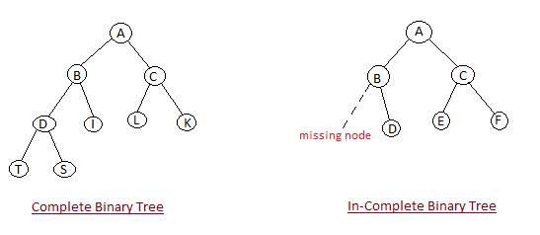
- Heap Property: All nodes are either [greater than or equal to] or [less than or equal to] each of its children. If the parent nodes are greater than their children, heap is called a Max-Heap, and if the parent nodes are smaller than their child nodes, heap is called Min-Heap.
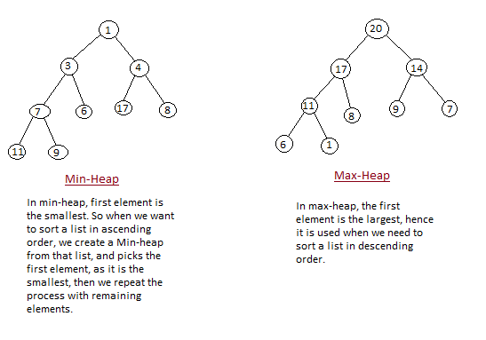

How Heap Sort Works
Initially on receiving an unsorted list, the first step in heap sort is to create a Heap data structure (Max-Heap or Min-Heap). Once heap is built, the first element of the Heap is either largest or smallest (depending upon Max-Heap or Min-Heap), so we put the first element of the heap in our array. Then we again make heap using the remaining elements, to again pick the first element of the heap and put it into the array. We keep on doing the same repeatedly until we have the complete sorted list in our array.
In the below algorithm, initially heapsort () function is called, which calls buildheap () to build heap, which in turn uses satisfyheap() to build the heap.
Algorithm:

Four basic procedures on heap are
- Heapify, which runs in O (log n) time.
- Build-Heap, which runs in linear time.
- Heap Sort, which runs in O (n log n) time.
- Extract-Max, which runs in O (log n) time.

Heapify (A, i)
- l ← left [i]
- r ← right [i]
- if l ≤ heap-size [A] and A[l] > A[i]
then largest ← l
- else largest ← i
- if r ≤ heap-size [A] and A[i] > A[largest]
then largest ← r
- if largest ≠ i
then exchange A[i] ↔ A[largest]
- Heapify (A, largest)

BUILD_HEAP (A)
- heap-size (A) ← length [A]
- For i ← floor(length[A]/2) down to 1 do
- Heapify (A, i)

HEAPSORT (A)
- BUILD_HEAP (A)
2. for i ← length (A) down to 2 do
exchange A[1] ↔ A[i]
heap-size [A] ← heap-size [A] - 1
Heapify (A, 1)
Testing:
Test Conditions:
Given set of numbers as input. They should be sorted in ascending order.
Input:
Read set of numbers.
Output:
Perform Operations:
  - Heapify
  - Bulid_heap
  - Heap Sort

FAQs:
- What is Heap?
- What are the different sorting techniques?
- How heap sort is performed?
- What are the worst case, best case & average case performances?
Conclusion: Use of a heap sort algorithm implementation is done to sort given set of numbers.

